Commands in MySQL:-
1 DDL(Data Definition Language)
2 DML(Data Manipulation Language)
3 DCL(Data Control Language)
4 TCL(Transaction Control Language)
5 DQL(Data Query Language)

DDL(Data Definition Language) commands:
These are those commands which are related to structure of the table.
The commands which are followed by a table keyword are included into it.
DDL Commands:
- Create
- Drop
- Alter
- Truncate
- Rename

DML(Data Manipulation Language) commands:
These are related to the data stored in the table.
DML Commands:
- Insert
- Delete
- update

TCL(Transaction control Language) commands:
- Commit(save data permanently.)
- rollback(undo)
- savepoint(breakpoints)

DCL(Data Control Language) commands:
- Grant(give a permission)
- Revoke(to revoke the granted permission)

DQL(Data Query Language)
- Select

Datatypes in MySQL:
- Integer(int)---------decimal numbers
- Float--------pointing numbers….3.4
- Char……alphabate or any symbol
- Varchar(20)……..string(collection of characters.eg:- ”teknowell”)
- Date(used to insert date)
- Time(used to insert time)
- Timestamp(insert date and time at a time)
- Blob(used to insert image)----binary long object

Note: Char(20) 20 is the width: char means exact/fixed length storage. Occupy 20 space at any cost

Creating MySQL DATABASE:
MySQL is a Relational Database Management System
A relational database consists of different tables in which data is stored.
Such that there is minimal redundancy
A relational database also contains relationship or links to related tables.

To Create DB
Syntax:
Create database db_name;
Example:
Create database Employee;

To Show Previous Databases
Example:
Show databases;
Or
Show schemas;

Use Required DB:
Use database;

To Show The Current Working Database Name.
Select database();

To Show Number Of Tables With There Names In A Given DB.
Show tables;

To drop database:
Drop database database_name;

Create Table
Syntax:
Create table tablename
(
Column1 data_type,
Column2 data_type,
.
.
Columnn data_type
);

Example:
Create table Employee
(Eid int primary key,
Name varchar(20) not null,
Age int not null,
Gender varchar(20)not null,
Designation varchar(20) not null,
Salary int not null
);
Select Data:
Syntax:
Select * from table_name;

Example:
Select * from Employee;

As compare to a DBMS, RDBMS stores data in different tables to ensure consistency and faster search and retrieval operations
A table stores data in rows and columns
A field in a table is called a column and row is called a record
A record is also defined as collection of fields.

How Insert Data In MySQL Table:
The insert into statement is used to insert new records in a table.

Insert Data Syntax:
It is possible to write the insert into statement in two ways:
The first way specifies both the column names and the values to be inserted:
Insert into table_name(column1, column2,…………………….column n) values(value1,value2,………………..value n) ;

Example:
Insert into Employee(Eid,Name,Age,Gender,Designation,Salary) values(1,’Sagar’,34,’Male’,’Manager’,80000);
Second way:
Insert into Employee values(2,’Naman’,33,’Male’,’Clerk’,20000);
Note:
Above insert command does not accept null value because all keys are not null.

To Show All Data
Select * from Employee;

Example:-
Create table Student(
Rno int primary key,
Name varchar(20),
Marks int
);

Insert into Student(Rno,Marks) values(1,’Jay’) ;
Note: It accept null values for first time. But inside a table it take it as a 0.
If you again enter same command for new data then it gives you error “duplicate entry for 0”.

If you are adding values for all the columns of the table, you do not need to specify the column names in the SQL query.
However, make sure that the order of the values is in the same order as the columns in the table.
The insert into syntax would be as follows:
Insert into Employee values(2,’Naman’,33,’Male’,’Clerk’,20000);
We can insert rows in a batch.
Example:
Insert into Employee values
(3,’Ajay’,33,’Male’,’Manager’,90000),
(4,’Nikita’,30,’Female’,’Developer’,40000),
(5,’Neha’,33,’Female’,’Tester’,30000),
(6,’Ajay’,33,’Male’,’Peon’,10000);

Auto_increment and Offset for primary key:
Note:
- Offset means starting value
- Increment means distance between two values
- When the value of auto_increment_offset is greater than that of auto_increment_increment, the value of auto_increment_offset is ignored.
- SET @@auto_increment_increment=100;
- SET @@auto_increment_offset=10;

To check both limitation use:
show variables like 'auto_inc%';
O/p:
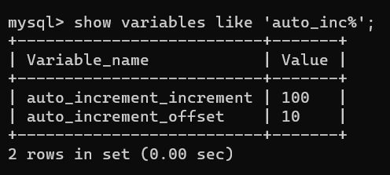
Example:
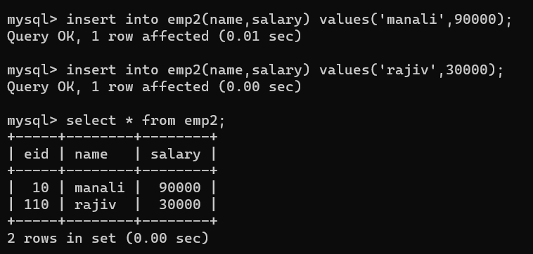

How to upload any .csv file data into mysql table:
Note:
1 Perform all above steps on normal cmd only
mysql –local_infile=1 -u root -p
2 set global local_infile=1;
3 use pawan;
4 select * from student;
5 create a file data.txt
6 Check the secure location from mysql use the following command:
SHOW VARIABLES LIKE 'secure_file_priv';
7 Save it on
C:\ProgramData\MySQL\MySQL Server 8.1\Uploads
8 insert the following command to check local_infile on or not
SHOW global VARIABLES LIKE 'local_infile';

9 Open my.ini from below location and add the given lines
C:\ProgramData\MySQL\MySQL Server 8.1
[mysqld]
local_infile=1

10 LOAD DATA local INFILE 'C:/ProgramData/MySQL/MySQL Server 8.1/Uploads/data.txt' INTO TABLE student fields terminated by ',' lines terminated by '\n' ignore 1 rows (rno,name,marks);
if you not want to delete the top row then use
LOAD DATA local INFILE 'C:/ProgramData/MySQL/MySQL Server 8.1/Uploads/data.txt' INTO TABLE student fields terminated by ',' lines terminated by '\n' (rno,name,marks);
Or use below command:
load data local infile "C:/ProgramData/MySQL/MySQL Server 8.1/Uploads/data1.csv"
into table student
fields terminated by ','
enclosed by '"' //its optional
lines terminated by '\n'
ignore 1 rows;

Delete Data From MySQL:
The delete statement is used to delete existing records in a table.
Delete Syntax:
Delete from table_name where condition;
Example:
Delete from Employee where Eid=5;
Delete from Employee where Name=’Ajay’;
Note:
Be careful when deleting records in a table! Notice the WHERE clause in the DELETE statement. The WHERE clause specifies which record(s) should be deleted. If you omit the WHERE clause, all records in the table will be deleted!
Syntax:
Delete from table_name;
Example:
Delete from Employee;
Delete from Employee where Designation=’Manager’;

Delete Multiple Records
Delete from employee where salary in(10000,3000,2000);

MySQL Select Statement:
The MySQL select statement is used to select, retrieve data from a database.
The data returned is stored in a result table, called the result-set.
If you want to select all the fields available in the table,
use the following syntax:
Select * from table_name;

Example:
Select * from Employee;
Select * from Employee where Eid=3;

If you want to select/retrieve particular fields available in the table, use the following syntax:
Select column1,column2…………….. from tablename
Example:
Select Eid, Name, Gender from Employee;

Order By keyword:
The Order By keyword is used to sort the result-set in ascending or descending order.
The Order By keyword sorts the records in ascending order by default.
To sort the records in descending order, use the DESC keyword.
Example:
Select * from Employee order by Name;
Select * from Employee order by Name Asc;
Select * from Employee order by Name Desc;

Order By several Columns Example:
Syntax:
Select * from table_name order by column1, column2;
Syntax:
Select * from table_name order by column1 Asc, column2 Desc;
Example:
Select * from Employee order by name,Age;
Select * from Employee order by name Asc, Age Desc;

MySQL Limit Clause:
In MySQL the limit clause is used with the SELECT statement to restrict the number of rows in the result set. The limit clause accepts one or two arguments which are offset and count. The value of both the parameters can be zero or positive integers.
Offset: It is used to specify the offset of the first row to be returned.
Count: It is used to specify the maximum number of rows to be returned.

Example:
Select * from Employee limit 3;
Select * from Employee limit 1,3;

MySQL OFFSET Clause:
SELECT * FROM student limit 3 offset 2;
Above query shows next 3 records from third position
Offset means leave first records how you pass after offset command.

Distinct Keyword:
To display unique information from columns using DISTINCT.
Keyword with select command, use the syntax:
Select distinct column_name from table_name;

Example:
Select distinct Name from Employee;

Select Command Using WHERE Clause:
The where clause contains one or more conditions that must be satisfied before the query retrieves a row.
The WHERE clause uses logical and conditional operators in the query.
The Syntax to specify a condition using the WHERE clause is:
Select * from table_name where <Condition to satisfy>;

Example:
Select * from Employee WHERE Salary>60000;
Select * from Employee WHERE Salary>=60000;
Select * from Employee WHERE Salary<60000;
Select * from Employee WHERE Salary<=60000;

Match() in MySQL:

Before applying match() create a fulltext index
Query:-
Display name and description of those whose course description contains ‘database’.
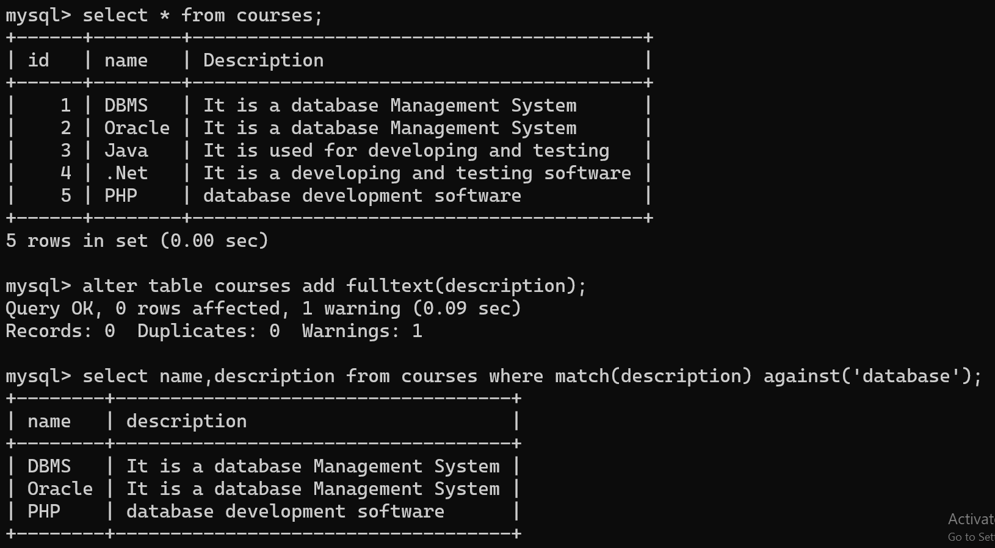

Display name and description of those courses who contains “system and software”.
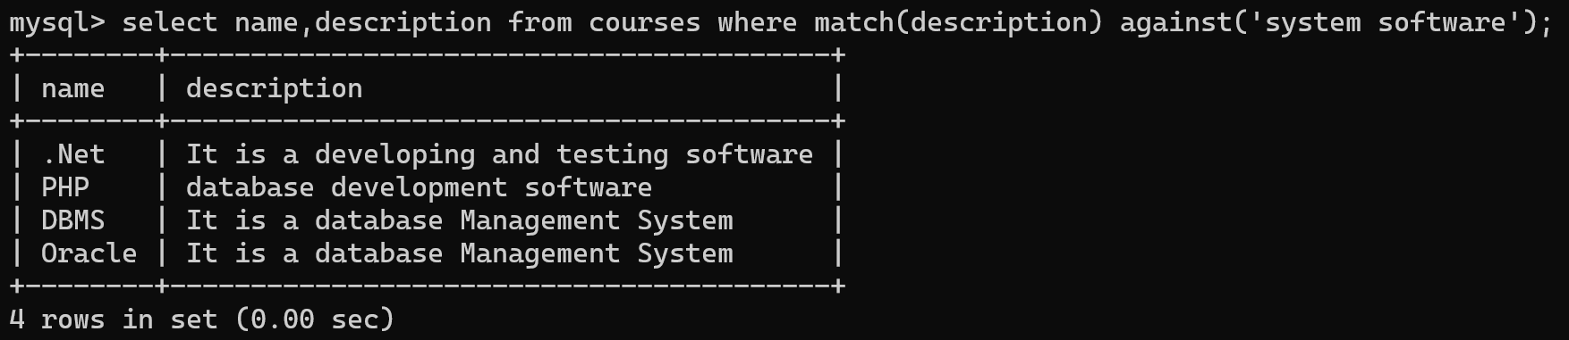

Find out exact match

Rollup(): It works with aggregate functions
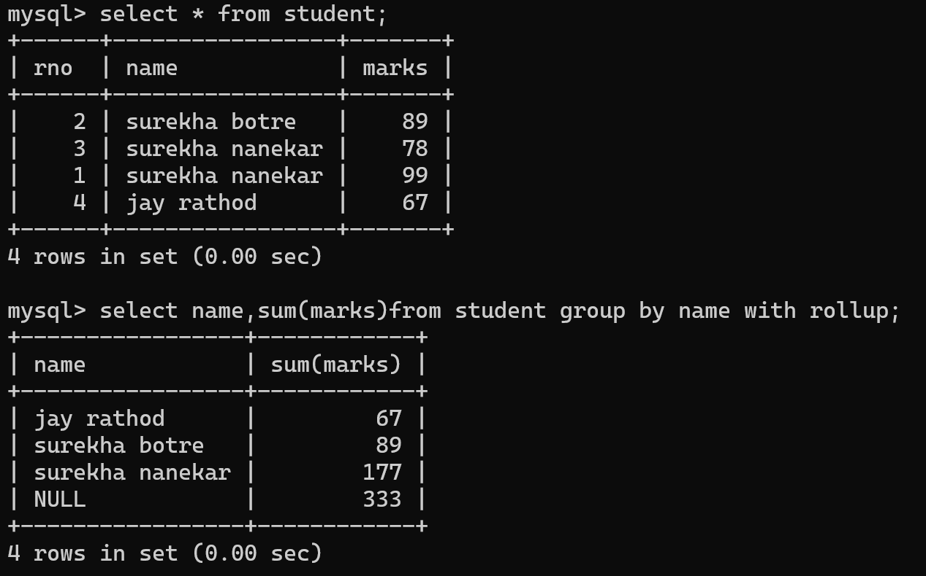

Show Command in MySQL:
You will use the SHOW command to display the list of databases and index keys along with the privileges.
The SHOW command provides information about databases, tables, columns, and server status.
To view a list of databases present on the server, use the

Following Syntax:
SHOW DATABASES;
To view a list of databases that begin or contain specified characters in the database name,
Use the following Syntax:
Show Databases[Like<condition>];

Like Clause:
The Like clause can use conditions with wildcard characters such as ‘%’ and ‘_’.
This clause is optional.
The ‘%’ represents any string of zero or more characters.
The ‘_’ represents any single character

Example:
show databases like 's%';-------------------------------> it means DB name starts with s.
show databases like 's__%';---------------------------------------->
It means DB name starts with s and contains two characters.

To view a list of tables in a database, use the following syntax:
Show Tables[from database_name][Like<condition>];

Example:
Use Db_Name;
1 Show tables;
2 show tables from DB_Name;
3 show tables from surekha like 's%';
4 show tables from Information_Schema like 's%';

To view the column structure of a table from the database, use the following Syntax:
Show columns from table_name [from database_name] [like clauses];

Example:
- show columns from student from surekha;
- show columns from student from surekha like 'm%';
- show columns from student from surekha like 'r__%';

To View The Index In A Table From A Database, Use The Following Syntax:
Show Index from table_name[from database_name];

Example:
show index from employee from surekha;

Alter Statement In MySQL:
MySQL provides the ALTER TABLE command to modify the structure of a table.
You can add or delete columns, rename columns or the table, create or destroy indexes, and modify the column type.
The ALTER TABLE command creates a temporary copy of the original table, on which the alteration is performed.
MySQL uses this feature as a security measure to prevent data loss in case the table modification fails.
Syntax:
ALTER TABLE table_name ADD column_name data_type;

Example:
Alter Table Employee ADD city varchar(20) not null;
Update Employee Set city=’Pune’ where Eid=1;

Modify Table definition using alter:
The syntax to add a primary key to the column of a table is:
Alter table table_name add primary key (index_column_name);

Example:
Alter table Student add primary key(Rno);

To Modify Column Data_Type:
Syntax:
Alter table table_name modify column column_name data_type;
Example:
Alter table student modify column Name(varchar(30)) not null;

Delete Column From table:
To delete a column in a table, use the following syntax(notice that some database systems don’t allow deleting a column):
Syntax:
Alter table table_name drop column column_name;
Example:
Alter table Employee drop column city;
Adding Column At Particular Location:
Syntax:
Alter table table_name Add column column_name data_type after column_name;
Example:
alter table Employee add column city varchar(20) not null after ename;

Adding Column At First Location:
Syntax:
Alter table table_name Add column column_name data_type not null first;
Example:
alter table Employee add column designation varchar(20) first;
Note: No need to use column keyword.

Dropping Primary key:
To drop a primary key of a column from the table, use the following Syntax:
Alter table table_name drop primary key;
Example:
Alter table Employee Drop primary key;
Note:
Primary key not deleted easily if you are assigning auto increment to it…And that’s why we use the following syntax:
Alter table student modify rno int;
Alter table student drop primary key;
OR
Alter table student drop primary key,change rno rno int;

Deleting Table definition:
MySQL provides the DROP TABLE command to remove or delete tables from a database.
This command removes table definition, data, indexes, triggers, constraints, and permissions for that table.

Example:
Drop table Employee;
MySQL Constraints And Unique Constraints
MySQL constraints are used to specify rules for data in a table.
Constraints can be specified when the table is created with the CREATE TABLE statement, or after the table is created with the alter table statement.
Sometimes, you want to enforce the uniqueness value in a column.
To enforce this rule, you need to use the UNIQUE constraint.
The UNIQUE constraint is either column constraint or table constraint that defines a rule that constraints values in a column or a group of columns to be unique.
UNIQUE column can contain NULL values.

Syntax-1:
Create table table_1
(Column_name_1 data_type UNIQUE);
Example:
Create table Emp(id int unique,name varchar(10),age int);
insert into student values(1,'jay',89);
insert into student values(2,'Ajay',89);
insert into student values(3,'Ajay',89);
insert into student values(3,'Naman',89);
ERROR 1062 (23000): Duplicate entry '3' for key 'student.id'

Syntax-2:
Create table table_1(
Column_name_1 data_type,
UNIQUE(column_name_1));
Example:
create table student(id int,name varchar(20),marks int,unique(id));
insert into student values(1,'jay',89);
insert into student values(2,'Ajay',89);
insert into student values(3,'Ajay',89);
insert into student values(3,'Naman',89);
ERROR 1062 (23000): Duplicate entry '3' for key 'student.id'

Syntax-3:
Create table table_1(column_name_1 data_type,
Column_name_2 data_type,
Column_name_3 data_type,
UNIQUE(column_name_1,column_name_2)
);

Example:
create table student(id int,name varchar(20),marks int,unique(id,name));
insert into student values(1,'jay',89);
insert into student values(2,'Ajay',89);
insert into student values(3,'Ajay',89);
insert into student values(3,'Ajay',89);
ERROR 1062 (23000): Duplicate entry '3-Ajay' for key 'student.id'

Syntax-4:
Create table table_1(
Column_name_1 data_type,
Column_name_2 data_type,
CONSTRAINT constraint_name UNIQUE(column_name1, column_name_2)
);

Example:
create table student(id int,name varchar(20),marks int,CONSTRAINT key1 UNIQUE(id, name));
insert into student values(1,'jay',89);
insert into student values(2,'Ajay',89);
insert into student values(3,'Ajay',89);
insert into student values(3,'Naman',89);
insert into student values(3,'Ajay',89);
ERROR 1062 (23000): Duplicate entry '3-Ajay' for key 'student.key1'

UNIQUE CONSTRAINT IN MYSQL
What if you want to add a UNIQUE constraint to a table that already exists?
To do this, you use the ALTER TABLE statement as follows:
ALTER TABLE table_name ADD CONSTRAINT constraint_name UNIQUE(column_list);
Example:
alter table student add constraint key1 unique(id);
alter table student add constraint key1 unique(id,name);

Create constraint using given so that you can delete it easily:
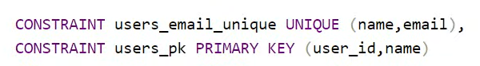
Remove Unique Constraint:
To remove a UNIQUE constraint, you can use DROP INDEX or ALTER TABLE statement as follows:
DROP INDEX index_name ON table_name;
ALTER TABLE table_name DROP INDEX index_name;

NOT NULL CONSTRAINT IN MYSQL
The NOT NULL constraint is a column constraint that forces the values of a column to non-NULL values only.
The syntax of the NOT NULL constraint is as follows:
Column_name data_type NOT NULL;
A column may contain one NOT NULL constraint only, which specifies a rule that the column must not contain any NULL value.
Example:
create table student(id int,name varchar(20) not null,marks int);
insert into student(id,marks) values(1,77);
ERROR 1364 (HY000): Field 'name' doesn't have a default value
Add A NOT NULL Constraint To Existing Column:
Typically, you add a NOT NULL constraint to columns when you create the table. However, sometimes, you want to add a NOT NULL constraint to NULL-able column of an existing table. In this case, you use the following steps:
- Check the current values of the column.
- Update the NULL values to non-null values.
- Add the NOT NULL constraint.
ALTER TABLE table_name CHANGE old_column_name name_column_name new_column_definition;

Example:
alter table student change marks marks int not null;

To View The Structure of Table:
describe student;
OR
Desc student;

Note: To remove NOT NULL use the same above query.
Example:
alter table student change marks marks int;
CHECK CONSTRAINT IN MySQL
MySQL standard provides you with CHECK constraints that allow you to available data for a column or a group of columns before insert and update.
CREATE TABLE Person(Age int CHECK(Age>=18));
Example:
create table student(id int,name varchar(20) not null,marks int check(marks>0));
OR
create table student(id int,name varchar(20) not null,marks int, check(marks>0));
OR
create table student(rno int primary key, name varchar(30),marks int,constraint m1 check(marks>35));
OR
Use above most of the time to delete constraint easily.
alter table student drop constraint m1;
insert into student values(1,'sameer',99);
insert into student values(2,'sameer',0);
ERROR 3819 (HY000): Check constraint 'student_chk_1' is violated.

DEFAULT CONSTRAINT IN MySQL
The default constraint is used to provide a default value for a column.
The default value will be added to all new records IF no other value is specified.

Example:
create table student
-> (rno int,
-> name varchar(20) default 'Unknown',
-> marks int);
insert into student(rno,marks) values(1, 33);
select * from student;
+------+---------+-------+
| rno | name | marks |
+------+---------+-------+
| 1 | Unknown | 33 |
+------+---------+-------+

MySQL DEFAULT ON ALTER TABLE:
To create a DEFAULT constraint on the ‘CITY’ column when the table is already created, use the following syntax:
ALTER TABLE Person ALTER City SET DEFAULT ‘Hydrabad’;
alter table student alter marks set default 35;
Or
ALTER TABLE employees MODIFY status VARCHAR(50) DEFAULT 'active';

DROP A DEFAULT CONSTRAINT:
To drop a DEFAULT constraint, use the following
syntax:
Alter table Person alter city drop default;
Alter table student alter marks drop default;

PRIMARY KEY AND FOREIGN KEY IN MySQL:
A primary key is used to uniquely identify each row in a table.
A primary key specifies that there cannot be a column in a table that contains two similar values.
The primary key does not allow blank or NULL values for the column.
You must remember the following rules while defining a primary key:
- Contains a value and cannot contain a null value.
- Is Unique for each record
- Primary key is integer
- Only one primary key is allowed in one table

Example:
create table student(rno int primary key,name varchar(20) not null,marks int not null);

insert into student values(1,'naman',89);

insert into student values(1,'aman',89);
ERROR 1062 (23000): Duplicate entry '1' for key 'student.PRIMARY'
insert into student(name,marks) values('mayank',89);
ERROR 1364 (HY000): Field 'rno' doesn't have a default value
alter table student add primary key(name);
ERROR 1068 (42000): Multiple primary key defined

Drop Primary key:
alter table student drop primary key;

Add Primary key externally:
alter table student add primary key(rno);

AUTO_INCREMENT IN MYSQL:
Auto increment is a function that operates on numeric data types.
It automatically generates sequential numeric values every time that a record is inserted into a table for a field defined as auto increment.

WHEN USE AUTO_INCREMENT?
In the database normalization, we looked at how data can be stored with minimal redundancy, by storing data into many small tables, related to each other.

Example:
Create table Student(rno int primary key auto_increment, name varchar(30), age int);
Insert into student values(null,’surekha’,22);
Insert into student(name,age) values(’rekha’,21);

Example:
create table new_table(id int primary key auto_increment, name varchar(10));

alter table new_table auto_increment=100;

insert into new_table values(null,'jay');

select * from new_table;
+-----+------+
| id | name |
+-----+------+
| 100 | jay |
+-----+------+

Renaming Table Name:
Syntax:
Rename table old_table_name to new_table_name;
OR
Alter table old_table_name rename new_table_name;

Example:
Rename table product to product1;
Alter table product1 rename product;

Renaming Column Name:
alter table table_name rename column old_column_name to new_column_name;
O
Alter table table_name change old_column_name new_column_name data_type;

Example:
alter table product rename column cost to price;
OR
Alter table product change price cost int;

Aggregation OR Scalar Functions In MySQL:
MySQL aggregate functions perform a calculation on a set of values and return a single value.
Aggregate functions operate on a group of values and return a single value as the final result.
- SUM()
- MAX()
- MIN()
- AVG()
- COUNT()
- COUNT(DISTINCT COLUMN_NAME)

Example:
Select sum(salary) from employee;

Alias: to change the result heading name
Select sum(salary)as Total_Salary from employee;
Select max(salary)as Max_Salary from employee;
Select min(salary)as Min_Salary from employee;
Select avg(salary)as Average_Salary from employee;
Select count(name)as Total_Rows from employee;
Select count(*)as Total_Rows from employee;
Select count(distinct name)as Unique_Rows from employee;

MySQL provides many aggregate functions that include AVG(), SUM(), MAX(), MIN(), COUNT(), etc. AN aggregate function ignores NULL values when it performs calculation except for the COUNT function.

GROUP BY clause:
You can use GROUP BY to group values from a column, and, if you wish, perform calculations on that column.
The GROUP BY statement is used with aggregate functions to group the result-set by one or more columns.
You can use aggregate functions like COUNT,SUM(),AVG(), etc. functions on the grouped column.
We can select only those columns which were present in GROUP BY command.
We can use one or more than one column in a GROUP BY clause.

Example:
Select sum(salary) from employee group by city;
Select city, sum(salary) from employee group by city;
Select city, gender, sum(salary) from employee group by city, gender;
Select gender, count(*) from employee group by gender;
Select gender, designation count(*) from employee group by gender, designation;

HAVING CLAUSE
Having clause is used to specify conditions like where clause.
But having clause is used with group by command.
We cannot use where clause with group by command.
Where clause is used for filtering rows and having clause is used to filtering groups.
Where clause does not work with aggregate functions like sum, max, min, etc.
We can use having clause with aggregate functions.
Where clause can be used before the group by clause but not after that.
We can use where and having together in a single query.
From the point of view of performance having is slower than where and should be avoided when possible.
Some aggregate functions work with the group by and having clause.

Select city, sum(salary) from employee group by city having in(‘Hydrabad’, ‘Kolkatta’);
Select city, sum(salary) from employee group by city having not in(‘Hydrabad’, ’Kolkatta’);

Select city, sum(salary) from employee where city not in(‘Hydrabad’, ‘kolkatta’) group by city;
OR
Select city, sum(salary) from employee group by city having city not in (‘Hydrabad’, ’kolkatta’);

Delete details of those whose salary is max.
delete from employee where salary in(select * from(select max(salary) from employee) e);
Note:
You cannot delete details of those employee whose salary is max using normal query. And that’s why we need to create a dummy table as e.
You can use the following query also but it takes two steps:
First create a temporary table
Create temporary table e as select max(salary) from employee;
Then delete records from that table whose salary is max which is stored inside a temporary table e.
Delete from employee where salary in(select max(salary) from e);
Note:
Note that once you create a temporary table it is visible till you are not closing the MySQL. Once you close and reopen it, It is not visible to us.
Note: Both gives same result
Select city, sum(salary) from employee group by city having sum(salary)>45000;
Select city, sum(salary) from employee where city in(‘Hydrabad’,’Karachi’) group by city having sum(salary)>45000
Select city, sum(salary) from employee where city not in(‘Hydrabad’,’Karachi’) group by city having sum(salary)>45000

Like operator with wild cards(‘%’, ‘_’):
The like operator is commonly used to select data based on patterns. Using the like operator in the right way is essential to increase the query performance.
The LIKE operator allows you to select data from a table based on a specified pattern. Therefore, the LIKE operator is often used in the WHERE clause of the SELECT statement.

Example:
Select names which starts with ‘a’.
Select * from employee where name like ‘a%’;

Select names which s with ‘a’.
Select * from employee where name like ‘%a’;

Select names which starts with ‘a’ and ends with ‘a’
Select * from employee where name like ‘a%a’.

Select names which contains ‘a’
Select * from employee where name like ‘%a%’;

Select names which starts with ‘a’ and contains three characters.
Select * from employee where name like ‘a_ _ _ %’;

Select names which ends with ‘a’ and contains three characters.
Select * from employee where name like ‘_ _ _ %a’;

Select names of those whose names second character is ‘a’.
Select * from employee where name like ‘_ a%’;

WILDCARDS IN LIKE OPERATOR:
MySQL provides two wildcard characters for using with the like operator, the percentage % and underscore _.
The percentage (%) wildcard allows you to match any string of zero or more characters.
The underscore(_) wildcard allows you to match any single character.

Nested Queries:
Select name of those employee whose salary is max
Select name from employee where salary in(select max(salary) from employee);
OR
Select name from employee where salary=(select max(salary) from employee);

Select 2nd maximum record from database
->Select * from employee where salary=(select max(salary) from employee where salary<(select max(salary) from employee));
->Select max(salary) from employee where salary not in (select max(salary) from employee);

Create a table Employee (Eid,ename,dept,salary)

Write a query to display all the dept names along with no of employee working in that?
=>Select dept,count(*) from employee group by dept;

Write a query to display all the dept names where no of employees are less than 2
=>Select dept from employee group by dept having count(*)<2;

Select name of those whose no of department is 2
=>select name,dept from employee group by dept having count(dept)=2;

Select name of those whose no of department is <2
Select name from employee where dept in(Select dept from employee group by dept having count(*)<2);

VIEWS:
Create views
Create view employeedata as select eid,name from employee;

Select * from employeedata;

Alter view
Alter view employeedata(eid,name,salary) as select eid,name,salary from employee;

Select * from employee;

Note: if you are creating a view first time then we cannot use same name for new view creation but if you want to reuse previous view name then use the following command

=>create or replace view e1 as select * from employee;

Difference between while and having
Where | having
Used to check condition on individual rows | Used to check conditions on groups
Is executed before groups are created | Executed after groups are formed
Select max(marks) from student where age>15 group by class | Select class,max(marks) from student group by class having count(*)>2

CHAPTER-3

Built-In FUNCTIONS:
ADDDATE FUNCTION:
The Adddate function adds two date expressions.
The syntax for adding two date expression is:
Select adddate(expr1,expr2);
To add 20 days to the date 2000-12-09,
Enter the following command:
SELECT ADDDATE(‘2000-12-09’,20);

ADDTIME FUNCTION
The addtime function is used to add two time expressions.
The syntax for using this function is:
Select ADDTIME(expr1,expr2);
To calculate the addition of 20:10:25 and 01:02:35,
Enter the following command:
Select ADDTIME(’20:10:25’,’01-02-35’);

CURDATE FUNCTION
The curdate function return the current date in the YYYY-MM-DD fromat.
The Syntax to retrieve the current date is:
Select curdate();

CURTIME FUNCTION
The curtime function displays the current time.
The syntax to view the current time is:
Select curtime();
The alternative syntax for viewing the current time is:
Select CURRENT_TIME();
It returns time in 24 hours format.

DATE FUNCTION
The DATE function displays the date part of the specified date.
Syntax:
Select DATE(expression);
For example, to view only the date part from 2007-11-12 21:00:00
Enter the following code:
SELECT DATE(‘2007-11-12 21:00:00’);

DATE_FORMAT FUNCTION
These function displays the specified date in a particular format.
The syntax to use this function is:
SELECT DATE_FORMAT(date, format);
To display a particular date in the MM-DD-YYYY format,
Enter the following command:
SELECT DATE_FORMAT(‘1999-11-04’,’%M-%D-%Y’);
SELECT DATE_FORMAT(CURRENT_DATE(),’%M-%D-%Y’);

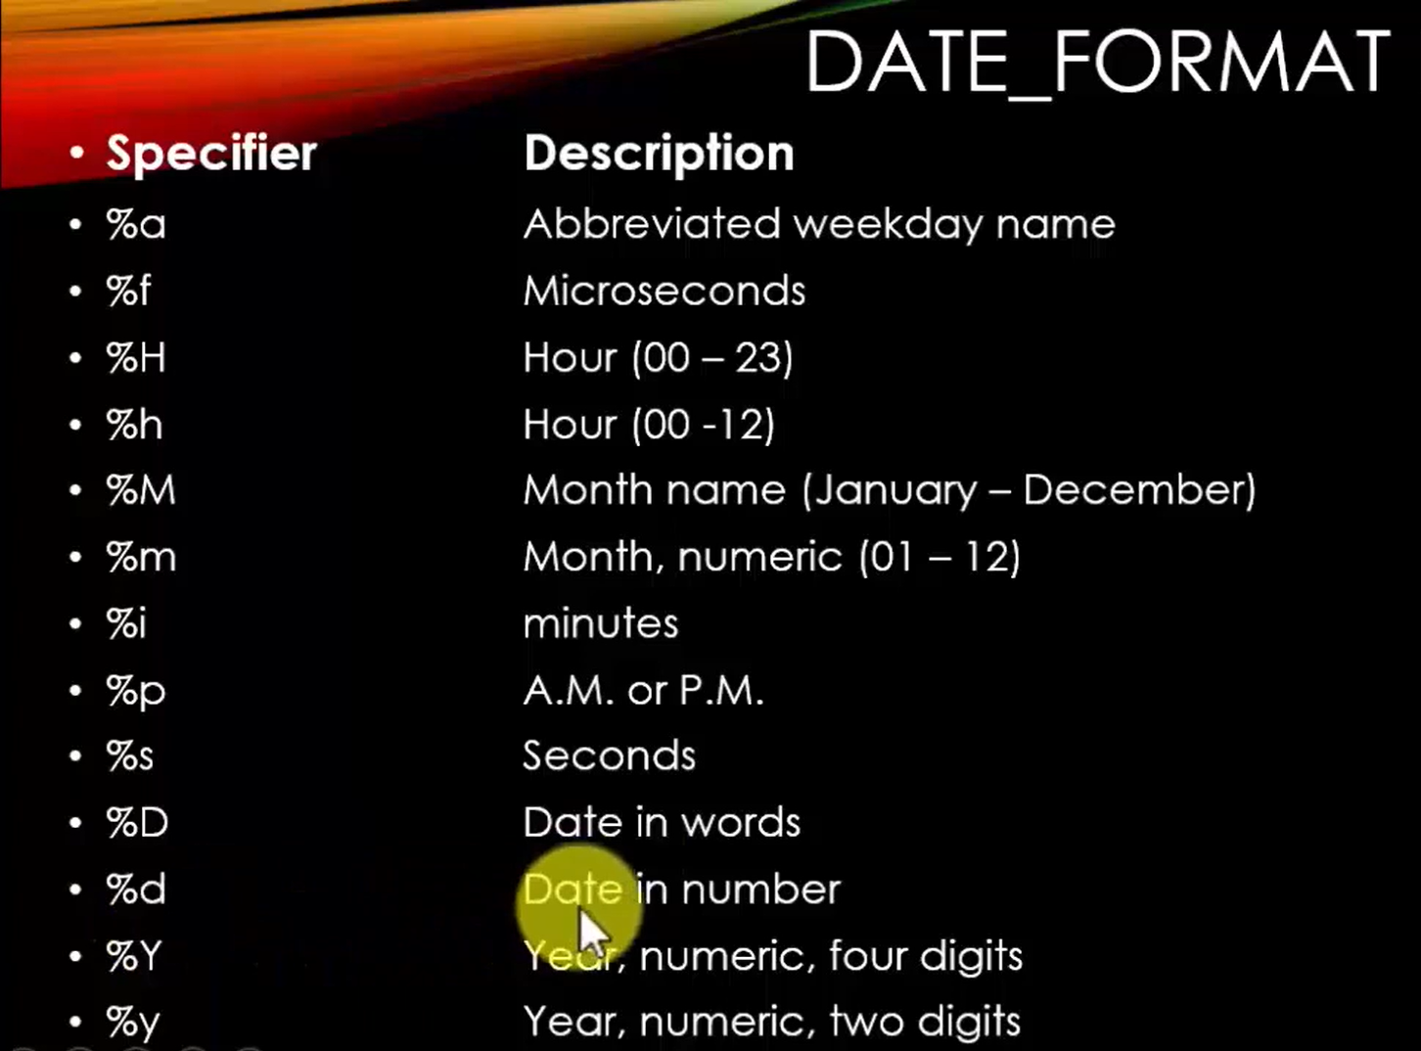

SELECT TIME_FORMAT(CURRENT_TIME(),’%h:%i:%s %p’);

DAY FUNCTION
The DAY function returns the day of the month for the specified date.
The range is from 1 to 31.
The syntax to display the day of the month is:
SELECT DAY(date);
For example, to obtain the day for the date 2004-08-15,
Enter the following command:
SELECT DAY(‘2004-08-15’);

DAYNAME FUNCTION
The DAYNAME function returns the name of the weekday for a date entered as an argument.
The syntax to display the name of the weekday is:
SELECT DAYNAME(date);
For example, to obtain the name of the day for the date
2002-05-09,
Enter the following command:
SELECT DAYNAME(‘2002-05-09’);

HOUR FUNCTION
The HOUR function returns the hour of the time specified as an argument.
The Syntax for this function:
SELECT HOUR(expression);
For Example, to retrieve the hour from the expression
21:05:57,
Enter the following command:
SELECT HOUR(’21:05:57’);

MINUTE FUNCTION
The MINUTE function extracts the minutes from the specified time argument.

The Syntax For This Function Is:
SELECT MINUTE(expression);
For example, to display the minutes from a datetime expression,

Enter the following command:
SELECT MINUTE(’09:30:55’);

MONTH FUNCTION
The month function extracts the month from the specified argument.
The output of this function is a numeric value ranging from 1 to 12
Syntax:
SELECT MONTH(expression);
For Example, to display the month from the datetime expression 1993-11-22, enter the following command:
SELECT MONTH(‘1993-11-22’);

MONTHNAME FUNCTION
The MONTHNAME function returns the name of the month for the date passed as an argument.
Syntax:
SELECT MONTHNAME(date);

For Example, to display the name of the month for the date
2006-07-03 ,
Enter the following command:
SELECT MONTHNAME(‘2006-07-03’);

NOW FUNCTION
The NOW function returns the current date and time
The output of this function is in the YYYY-MM-DD HH:MM:SS, and the value is expressed in the current time zone.
Syntax:
To view the current date and time value is
SELECT NOW();
SELECT date_format(now(),’%D-%M-%Y’);
SELECT date_format(now(),’%d-%m-%y’);
SELECT date_format(now(),’%d-%m-%y %h:%i:%s %p’);

TIME FUNCTION
The TIME function displays only the time part of the specified date or timestamp.
Syntax:
SELECT TIME(expression);
For example, to display only the time from 2007-09-12 20:20:00,
Enter the following command:
SELECT TIME(NOW());

YEAR FUNCTION
The year function returns the year for the date specified in the argument
Syntax:
SELECT YEAR(date);
Example:
To display the year from the date 2000-09-09,
Enter the following command:
SELECT YEAR(‘2000-09-09’);
SELECT YEAR(CURRENT_DATE());

CONCAT FUNCTION:
The CONCAT function returns a string after joining the specified argument.
This function returns a NULL value if NULL arguments are specified.
The Syntax for this function is:
SELECT CONCAT(STR1,STR2,…..);
SELECT CONCAT(‘Surekha’,’Nanekar’);
SELECT CONCAT(‘Surekha’,space(2),’Nanekar’);

INSERT FUNCTION:
The insert function adds a new string to the existing string at a specified position.
The output of the function is also a string.
The syntax for the INSERT function is:
INSERT(str, pos, len, newstr);
Where,
Str-specifies the existing string.
pos- defines the starting position of the new string.
Len- specifies the length of the new string
Newstr- specifies the new string to be inserted.
Example:
SELECT INSERT(‘I am Fine’,6,9,’GOOD’);

INSTR FUNCTION:
The INSTR function works with two arguments, such as string and substring.
It returns the position of the first instance of a substring in a string.
The output of this function is a numeric value ranging from 0 to the length of the string
For Example,
To retrieve the position of the string cd from the string abcd,
Enter the following command:
SELECT INSTR(‘abcd’,’cd’);

LCASE FUNCTION:
The LCASE function changes all the characters of the values specified in the argument to lowercase.
To convert MYSQL to lowercase,
Enter the following command:
SELECT LCASE(‘MYSQL’);

LEFT FUNCTION:
The left function returns the leftmost characters of the values specified in the argument.
For example,
To obtain the first four character of the string DATABASE,
Enter the following command:
SELECT LEFT(‘DATABASE’,4);

LENGTH FUNCTION:
The LENGTH function returns the length of the string.
For example, to calculate the length of the string MySQL,
Enter the following command:
SELECT LENGTH(‘MYSQL’);

REPLACE FUNCTION:
The replace function modifies a part or whole of the string with the new string.
The syntax for this function is:
SELECT REPLACE(str,from_str, to_str);
Where,
Str- specifies the original string
From_str- defines the string to be replaced
To_str- defines the new string to be inserted
To change the string DATA to BETA,
Enter the following command:
SELECT REPLACE (‘DATA’,’DA’,’BE’);
SELECT REPLACE (‘DATA’,’DATA’,’BEWARE’);

REVERSE FUNCTION:
The reverse function inverts the sequence of characters in an argument.
The Syntax for this function is:
SELECT REVERSE(expression);
To change the order of character of the string XYZ,
Enter the following Command:
SELECT REVERSE(‘XYZ’);

RIGHT FUNCTION:
The right function accepts two arguments, such as string and length
The function returns an output that contains string values starting from the right end of the input string.
The Syntax for this function is:
SELECT RIGHT(‘database’,4);
For example, to obtain the last four character of the string database,
Enter the following command:
SELECT RIGHT(‘database’,4);
Design a query to print data in student_names ascending order by names last 3 characters.
select student_name,right(student_name,3) from student;
select student_name from student order by right(student_name,3);
STRCMP FUNCTION:
The STRCMP function accepts two string as arguments.
It compares the strings and returns a numeric value ranging from -1 to 1 in the output.
The function returns 0 if the strings have same values, -1 when the first argument is smaller than the second and 1 when the first argument is greater than the second.
The syntax for this function:
SELECT STRCMP(str1,str2);
Where,
Str1,str2- specifies the strings to compare
If str1= str2 the output is 0
If str1< str2 the output is -1
If str1> str2 the output is 1
To compare two strings data and database,
Enter the following command:
SELECT STRCMP(‘data’,’database’);

UCASE FUNCTION:
The UCASE function changes all the characters of the argument into uppercase.
The Syntax for this function is:
SELECT UCASE(expression);

JOINS IN MySQL:
Combining two or more records of different tables from the same database, into one comprehensive structure, is known as joining of tables.
Joining tables enables ease of manipulation, increase the speed of access, and reduces data redundancy.
The concept of joining tables is to display a single table that will be derived from the base of all related tables linked to each other with a common attribute.
You can join the tables either using the WHERE CLAUSE with the SELECT command or by using the JOIN keyword.
Types of JOINS:
- INNER JOIN
- LEFT JOIN(OR Left Outer Join)
- RIGHT JOIN(OR Right Outer Join)
- FULL JOIN(OR Full Outer Join)
- SELF JOIN
- CROSS JOIN
INNER JOIN:
The most common join operation used in application is an INNER JOIN.
An INNER JOIN creates a virtual table by combining the fields of both tables that satisfy the query for both the tables.
An INNER JOIN creates a virtual table by combining the fields of both tables that satisfy the query for both the tables.
Example:
select * from student;;
+-----+---------+
| rno | name |
+-----+---------+
| 1 | surekha |
| 2 | sahil |
| 3 | naman |
| 4 | jay |
| 5 | saha |
| 6 | sara |
| 7 | ajinkya |
| 8 | Ajay |
+-----+---------+
select * from Book;
+-----+--------+
| bid | bname |
+-----+--------+
| 1 | C |
| 2 | C++ |
| 3 | JAVA |
| 4 | PYTHON |
+-----+--------+
select * from student inner join book on student.rno=book.bid;
rno | name | bid | bname |
+-----+---------+-----+--------+
| 1 | surekha | 1 | C |
| 2 | sahil | 2 | C++ |
| 3 | naman | 3 | JAVA |
| 4 | jay | 4 | PYTHON

select rno,name,bname from student inner join book on student.rno=book.bid;
+-----+---------+--------+
| rno | name | bname |
+-----+---------+--------+
| 1 | surekha | C |
| 2 | sahil | C++ |
| 3 | naman | JAVA |
| 4 | jay | PYTHON |
+-----+---------+--------+
Note: If Column names are same then use it with table name like Student.id, Book.id
Syntax:
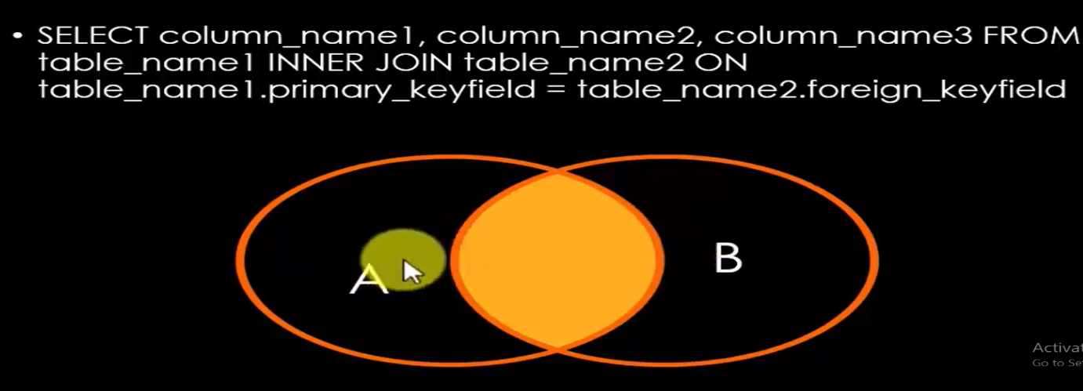
We can use alias names instead of table names.
We can use where condition to apply conditions on joins.
We can use like operator in where clause.
We can use IN and NOT IN operators in where clause.
We can use relational or comparison operator in where clause.

Display details of ‘surekha’ only
select rno,name,bname from student inner join book on student.rno=book.bid where name=’surekha’;
These command deletes matching rows from the tables specified in the FROM clause and before the USING clause.
DELETE from student using book inner join student on student.rno=book.bid;
Note: In these rows deleted from student table only
Delete records from both the tables:
delete customer,phone from customer inner join phone on customer.cid=phone.pid and cname like 'N%';

Nested Inner Joins:
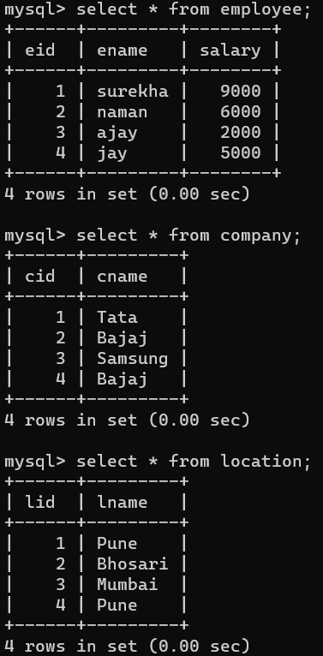

Example:
Display details of all the three tables.
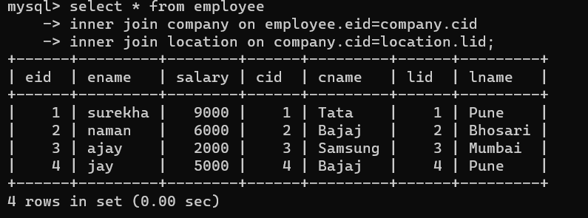

Display employee name, company name and location of those employee whose salary>5000.
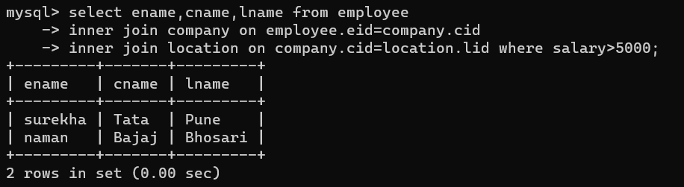
LEFT OUTER JOIN:
It is also known as LEFT OUTER JOIN. It displays all the records from the table specified on the left of the OUTER JOIN operator in the result set, with or without any matching records from the table specified on the right.
If no matching record is found in any of the rows from the table placed on the right, then the corresponding columns of that row will contain null values.

select * from student as S left join book as B on S.rno=B.bid;
RIGHT OUTER JOIN:

select * from student as S right join book as B on S.rno=B.bid;
It displays all records from the table specified on the right of the OUTER JOIN operator in the result set, with or without any matching records from the table specified on the left.
If there is no matching record found in any of the row from the table placed on the left, then the corresponding columns of that row will contain NULL values.

FULL OUTER JOIN
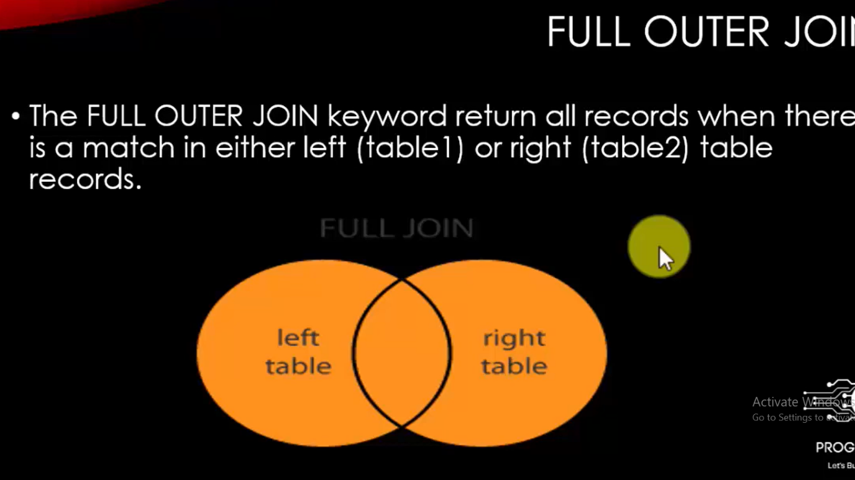
select * from student as S left join book as B on S.rno=B.bid
-> union
-> select * from student as S right join book as B on S.rno=B.bid;
+------+---------+------+--------+
| rno | name | bid | bname |
+------+---------+------+--------+
| 1 | surekha | 1 | C |
| 2 | sahil | 2 | C++ |
| 3 | naman | 3 | JAVA |
| 4 | jay | 4 | PYTHON |
| 5 | saha | NULL | NULL |
| 6 | sara | NULL | NULL |
| 7 | ajinkya | NULL | NULL |
| 8 | Ajay | NULL | NULL |
+------+---------+------+--------+



SELF-JOIN IN MySQL:
A self-join statement joins or compares a table with itself
It means that self-join compares records of a column with the other.
Self-join apply on single table only.
BEFORE APPLYING SELF-JOIN
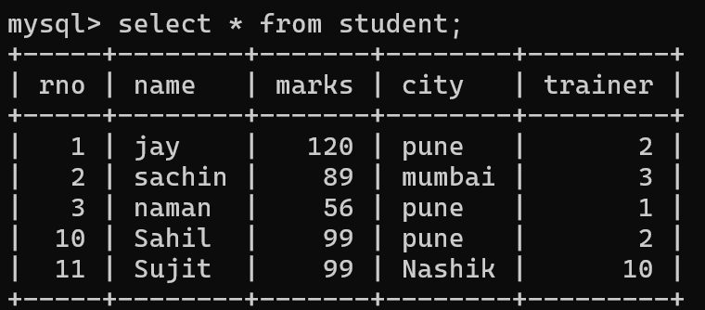
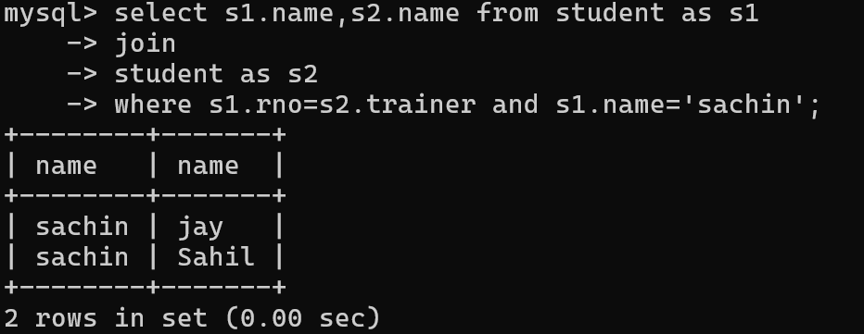

Example:
create table Employee(eid int,ename varchar(20),mid int);
insert into employee values
-> (1,'Ajay',4),
-> (2,'Naman',4),
-> (3,'Raj',5),
-> (4,'sahil',6),
-> (5,'raj',null),
-> (6,'manish',null);

select * from employee;
+------+--------+------+
| eid | ename | mid |
+------+--------+------+
| 1 | Ajay | 4 |
| 2 | Naman | 4 |
| 3 | Raj | 5 |
| 4 | sahil | 6 |
| 5 | raj | NULL |
| 6 | manish | NULL |
+------+--------+------+

select A.ename as employee,B.ename as manager from employee as A inner join employee as B on A.eid=B.mid;
+----------+---------+
| employee | manager |
+----------+---------+
| sahil | Ajay |
| sahil | Naman |
| raj | Raj |
| manish | sahil |
+----------+---------+

CROSS JOIN IN MySQL:
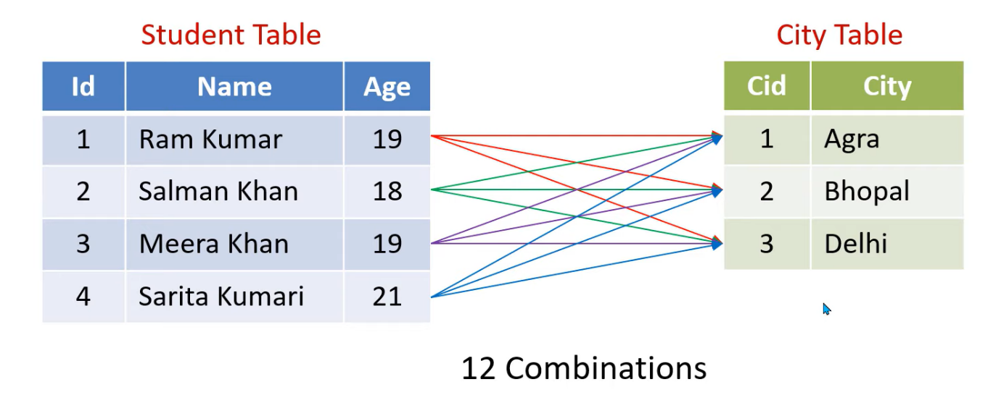
Syntax:
Select columns
from table1
cross join table2;

Example:
Select * from Student cross join City;
Example:
select s.name, c.City from student s cross join City c;

USER CREATION:
First select all previous users from system

Command:
Select user from mysql.user;

Create user for your particular system only
Syntax:
create user ‘username’@’localhost’ identified by ‘password’;

Example:
create user ‘surekha’@’localhost’ identified by ‘surekha123’;

Select user from mysql.user;

If you want to login from remote user then use its ip address
Command:
create user ‘aaradhya’@’10.4.9.7’ identified by ‘aaru123’;

Steps to login by newly created user:
1 goto c--------->program files-----------> MYSQL----------->MYSQL shell----------->bin--------->right click--------------->open with cmd
2 type command mysql -u aaradhya -p
3 enter password here:-aaru123
4 connected
5 show databases

Grant select on tek.employee to ‘aaradhya’@’localhost’;

Flush privileges;
goto c->program files-> MYSQL->MYSQL shell->bin->right click->open with cmd
type command mysql -u aaradhya -p

enter password here:-aaru123

Note: it allows aaradhya to select data but not allow to access remaining commands.

MYSQL ASSIGNMENT
Assignment-1:
create a table employee(eid,name,salary,city)
Design the following queries:-
1 display details of those whose name is 'sachin '
2 display details of those whose salary >45000
3 display name of those employee whose salary is 40000
4 display name of those whose city is 'pune'
5 display details of those whose city is 'pune' and 'nashik'
6 display details of those employee which are not belong to 'pune'.
7 display details of those whose city name starts with 'p'
8 display details of those whose name ends with 'a'
9 display details of those whose names second letter is 'i'
10 display details of those whose second last letter is 'a'
11 display details of those which contains 'sh'.
12 display details of those whose salary is between 20000 and 50000.
13 find out details of those whose salary less than 50000
14 display city of 'sachin' and 'manish'
15 display details of those whose city is 'pune' and salary>30000.
16 display details of those employees whose name starts with ‘a’,’s’ and ‘j’
->select * from employee where ename like ‘a%’ or ename like ‘s%’ or ename like ‘j%’;

Assignment-2:
Create table movie(mno mname,rel_yr,actor,income)
Design the following queries
1 display names of those movies which release after 2010
2 find out details of those whose actor is ‘yash’
3 display names and movies which are released in 2011
4 display details of those whose actor name ends with ‘h’
5 find out details of ‘shahrukh’.
6 display details of those whose income >6300000.
7 display those actor whose income >500000
8 find out details of those whose id’s >4
9 display name of those whose year is 2010,2013,2022.
10 display details of those movies whose actors third last letter is ‘m’
11 Find out details of ‘yash’,’amir’,’salmaan’.
12 Find out details of those whose name contains string ‘khan’
13 Find out details of those whose release year is in between 2000 to 2010.
14 find out details of those movies which are not release in 2010 to 2020.
15 Display Data in movies ascending as well as descending order.

Assignment-3:
1 Create table doctor(dno,name,speciality,city,income)
design the following queries
1 display details of those whose city is 'pune'
2 display details of those whose income is maximum
3 display details of those whose income is minimum
4 display names of those whose income is in between 200000 to 400000
5 display names and city of those doctors whose speciality is
'neuro' and 'heart'
6 display average income for all employee.
7 count total doctors which are belong to 'mumbai'
8 count city wise doctors
9 delete details of those whose salary>50000
10 add attribute no_of_patients to table11 change name of 'sachin' to 'sanjay'
12 delete primary key from given table
13 if city is not inserted by user side then consider it as a
'delhi'
14 If income <=0 then generate error
15 increase income of those doctors by 50000 whose
no_of_patients>60
16 find out details of 'those doctors whose no_of_patients'>90
17 delete details of those whose income <50000
18 select unique records from doctor table
19 count doctor wise total income.
20 display records according doctors city name.
21 select details of those whose income is second highest in
table
22 display details of those doctors whose occurance >1 times in table.

Assignment-4:
create table actor(aid,name,movie,income,rel_yr)
Design the following queries
1 display details of those actor whose movie is 'Dabang'
2 display total actors which are worked in 'KGF'
3 Display release year wise movies
4 find out details of those movies which are released after 2003
5 display names of those actors which worked in 'pathan'
6 A display names and income of those actors whose income is greater.
Ans:-select aname,sum(income)from actor group by aname having sum(income) >= all(select sum(income) from actor group by aname);
B display names and income of those actors whose income is less.
Ans:-select aname,sum(income)from actor group by aname having sum(income) <= all(select sum(income) from actor group by aname);
7 display details of those actor whose name starts with 's'
8 find out names of shahrukh movies.
9 count total actors which are worked in 'bahubali'
10 find out details of those actors whose name contains 'khan'.
11 display details of those whose income is between 900000,120000.
12 display total income of all the actors.
13 display actor wise income.
14 display details of first 3 actors.
15 display data in rel_year sequence.
16 find out those actors whose get max charge.
17 display names of those movies in which more than three actors work.
18 display average income of 'salmaan' and 'amir'.
19 display details of all except 'shahrukh'.
20 display movie wise actors.
21 display release year wise movies.

Assignment-5:
Create a table grossary(item_id,item_name,MRP_cost,retail_cost,qty,total_cost)
1 display details of those item whose sell is max.
select item_name,sum(qty)from grossary group by item_name having sum(qty)>=all(select sum(qty) from grossary group by item_name);
2 display details of those whose occurance greater.
3 display last 5 records of items.
4 display last selling item details.
5 display highest sell items details.
6 which product gives maximum income display it.
7 add 2% gst to all goods.
8 find out details of those which are sold after 25th date.
9 display details of those items which sold in first 10 days.
10 find out details of those whose cost is minimum.
11 display item wise quantity and cost.
12 display data according to cost.
13 display first 5 highest rated items.
14 display names of those items whose retail cost is greater.
15 delete details of those items whose cost >200.
16 display details of those items whose id is highest.
17 display details of 'wheat','rice' and 'sugar'.
18 display details of those whose qty>1000kg.
19 display daywise income we get from grossary shop.
20 display names of those items whose occurance >1
select group_concat(iname) from (select iname from grossary group by iname having count(iname)>1) as Total;

Assignment-6:
Create table employee(eid,name,address,salary,doj)
1 Display name of those employee whose salary is maximum
2 find second maximum salary of employee
3 retrieve all the information of employee whose name begins with ‘A’
4 select all the information of employee whose salary is 21000,11000 and 13000
5 create new table with the help of existing table data and structure
6 find all employee records whose salary is between 10000 and 15000
7 write a sql query to delete more than one records
8 insert record on a table using different ways
9 Arrange records of the table either ascending or descending
10 retrieve only unique records
11 update records of the table
12 how to add new column in database
13 how to count records of the table
14 how to increase salary of employee by 10%
15 how to update multiple columns
16 Display even number records
Select * from emp where eid %2=0;
17 Display odd number records
Select * from employee where eid %2!=0
18 Fetch first record from the table
Select * from employee where eid in(select min(eid) from employee);
19 Fetch first 2 records from employee
Select * from employee limit 2;
20 Fetch last record from employee table
select * from emp where eid in(select max(eid) from emp);
21 display 5 records from employee table
select * from employee limit 5
22 fetch first 50% records
Select * from employee where eid<=(select count(eid)/2 from employee);
23 fetch last 5 records
select * from employee limit 3,5;
24 display details of those whose salary is maximum and whose 5th last character is ‘a’.
25 Fetch details of employees whose lname ends with an alphabate ‘A’ and contains five alphabates.
26 display name of those company who spending maximum amount on their employees

Assignment- Query to search company name and total salary by avoiding those whose salary is maximum
Eid name salary company_name
1 surekha 20000 tata
2 sahil 30000 bajaj
3 manish 70000 tata
4 naman 9000 samsung
Select company_name,sum(salary) from employee group by company_name having sum(salary)!=max(salary);

Assignment-7:
create table college(cid,cname,branch,student_name,fees)
create different views for different branches
Note: branches names as(CE,ME,EE,CIE).
Each branch view contains cid,cname,branch,fees only for that
particular branch.
Assignment-8:
Create table Student(ID, Name, Course, Fees, Contact _No, Paid_Fees, Balance_Fees, Due_ Date).
Design the following queries:
1 Insert minimum 15 records to database.
2 Display name of those students whose fees is balance
3 Display names of those student whose due date is today’s date.
4 Display day wise fees to be paid and remaining due fees also.
5 Display course wise students.
6 Display course in which maximum number of students enrolled.
7 Display only those students who enrolled for “Full Stack Java Developer”. And display names in one row.
8 Find out those students whose enrolled for “Data Science” as well as “ASP.NET Developer”
9 Find out names of those students who enrolled for more than two courses
10 Design monthly day wise report on the basis of
Total no of student | Fees | Collection

11 If student paid the complete fees then add status as “Fees Complete”. If Not then add status as a due date
12 Display area wise students list. Which help me for marketing.
13 Find out weekly day wise admissions so that I can decide which day have a maximum enquiries to be done. For that one more column enquiries into the table.
14 Students who paid all the fees create a list of it.
15 Display names of those whose paid fees at the end of the month.

Assignment-9
Create table Product(pid,pname,cost)
Create table Customer(cid,cname,pid)
Design the following queries:
1 display name of those who purchase more than 2 products.
2 display name along with total cost of those student whose bill is higher.
3 display details of those customer whose products quantity is higher.
4 display average bill for all the customers.
5 count total customers.
6 display details of first five who purchase more products.
7 delete details of those customers whose bill is less.
8 apply 5% GST to all the products.
9 display name of those customers who purchase beauty products.
10 The customer who visited more than 5 times give him/her 1000rs discount on total bill.

Assignment-10
Create table Book(bid,bname,cost,author)
Design the following queries:
1 display name of those book whose author is ‘Fredy’.
2 display only those books who contains more than 500 pages.
3 display details of those author who write more than two books.
4 delete details of those books whose author is missing.
5 apply 20% discount on all the books.
6 delete details of those books whose cost is minimum.
7 display names of those books whose sell is max.
8 count books written by ‘Richard’.
9 find out details of those books whose cost is below the maximum cost.
10 find out details of those books whose cost is below the average cost.

Assignment-11
Create table Watch(id,brand,cost,warrenty_period,quantity)
Design the following queries:
1 display names of those watch whose warrenty period is above 5yrs
2 display only those watches whose cost is higher.
3 count total watches from “Sonata” brand.
4 Find out only those watches whose quantity is minimum.
5 display all the watches along with their cost from “reebook”,”JIT”,”Tanishq”
6 Display cost wise watches in ascending order.
7 display top 5 highest paying watches.
8 Find out details of those watches whose quantity is less than average quantity.
9 find out those watches whose name starts with ‘s’ and ends with ‘t’.
10 display names of those watches whose name contains ‘a’, ’j’,’r’,’t’.

